Circuit Planner for Event Technology
User Manual

About this manual
This manual describes the complete operation of the Circuit Planner for Event Technology (Schaltungs-Planer für Eventtechnik) — from signing in and drawing a schematic through to export, sharing and collaboration.
It is written to be read from start to finish as well as used for looking things up. Every cross-reference in the text is a hyperlink: one click jumps straight to the section named. The same applies to the table of contents and to the list of messages in the appendix.
Quick start: To simply draw a plan, read Signing in, Dashboard, The editor at a glance, Placing modules and Connecting — that is enough for a first complete schematic.
Language versions: This manual is available in German and English (Bedienungsanleitung_Schaltungsplaner_DE / User_Manual_Schaltungsplaner_EN), each as a Word and a PDF file, and as online help inside the application (the “?” button).
Note on the interface language: This manual describes the English interface. The screenshots still show the German interface; the layout is identical in both languages. Switch the interface language in Settings → Language or with the DE / EN switch in the editor toolbar.

Table of contents
- Introduction
- Signing in
- Dashboard
- The editor at a glance
- Placing and editing modules
- Connecting — drawing and routing cables
- Areas and text fields
- Module editor and module library
- Importing material, pack and plan lists
- Lists — pack list and connection list
- Export
- Sharing and collaborating
- Settings
- Public view
- Roles and permissions
- Keyboard shortcuts and mouse gestures
- Frequently asked questions and troubleshooting
- Appendix A: Cable types
- Appendix B: Categories
- Appendix C: Built-in modules
- Appendix D: Messages in plain language

1. Introduction

1.1 What the Circuit Planner does
The Circuit Planner is a pure web application for drawing signal and power schematics in event technology. Devices are placed on a canvas as modules with named inputs and outputs and are joined by cables. From the finished plan the application produces a pack list and a connection list as well as exports as image, vector, PDF or CAD file.
Core capabilities:
Area | What you can do | Chapter
Planning | Place modules from a library, snapping grid, zoom and pan | 4, 5
Connecting | Right-angled cable routing, waypoints, line hops, cable types | 6
Structuring | Coloured areas, text fields with images | 7
Own devices | Module editor with live preview, personal library | 8
Taking over data | Import of material lists (CSV/XLSX/DOCX/PDF/XML/JSON) and plans (DXF/MVR) | 9
Evaluating | Pack list, connection list, CSV and PDF output | 10
Handing on | PNG, JPG, SVG, PDF, DXF, MVR | 11
Working together | Share links with roles, presence display | 12
Adapting | Appearance, accessibility, cable types, categories, autosave | 13

1.2 System requirements
- A current browser (Chrome, Edge, Firefox or Safari) with JavaScript enabled.
- A working network connection to the server. The planner is a pure website and does not work offline — all project data is held on the server.
- An account in the PM Suite; sign-in and licensing run exclusively through it (see Signing in).

1.3 Structure of the interface
The application consists of these pages, reachable from the header bar or the user menu:
Page | File | Purpose
Sign-in | login.html | Signing in through the PM Suite
Dashboard | dashboard.html | Project overview, metrics, shared items
Editor | index.html | Drawing the plan
Module library | module-editor.html | Managing your own modules
Settings | settings.html | Personal settings
Help | help.html | This manual as online help
Public view | public.html | Share link without sign-in
Status | status.html | Licence and session information
Legal notice, terms of use, privacy policy | impressum.html, nutzungsbedingungen.html, datenschutz.html | Legal information, linked at the foot of the dashboard

2. Signing in
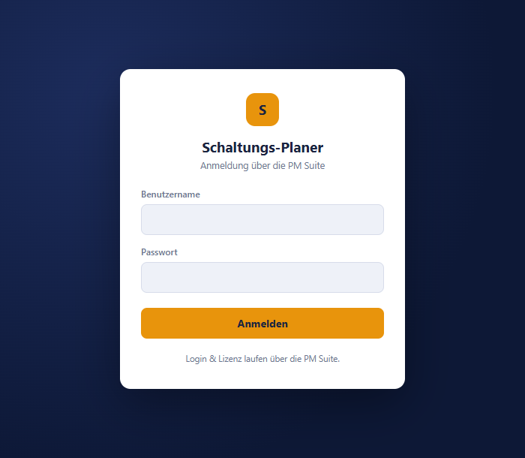
Sign-in page with user name, password and a note about the PM Suite connection

2.1 Signing in
- Open login.html in the browser.
- Enter Username and Password.
- Click “Log in”.
After a successful sign-in you land on the dashboard. If a valid session already exists, the sign-in page forwards you immediately without asking again.
Sign-in and licensing run through the PM Suite. You receive your user name and password from whoever manages your access — no accounts are created inside the planner itself. Your account type is shown on the status page.
Do not pass your credentials on. Access is personal. To work on a plan with others, invite them in the planner or create a share link — see Sharing.

2.2 Session, validity and signing out
- A session is valid for 12 hours; after that you have to sign in again.
- Protected pages verify the session before displaying anything at all. Without a valid session you are redirected to the sign-in page immediately — protected content never flashes up briefly.
- Signing out works in two ways: the “Log out” button in the dashboard header, or the user menu (click your avatar at the top right) → “🚪 Log out”.

2.3 Sign-in messages
These messages come from the server and are still shown in German.
Message | Meaning | Remedy
“Anmeldedaten ungültig …” (invalid credentials) | Wrong user name or password | Check the entry, mind upper and lower case
“Benutzername und Passwort erforderlich.” (user name and password required) | A field was empty | Fill in both fields
“Keine gültige PM-Suite-Lizenz.” (no valid PM Suite licence) | Licence status is not active | Check the licence in the PM Suite, see status page

3. Dashboard
The dashboard is the start page after signing in. It shows all your projects, key figures and everything that has been shared.
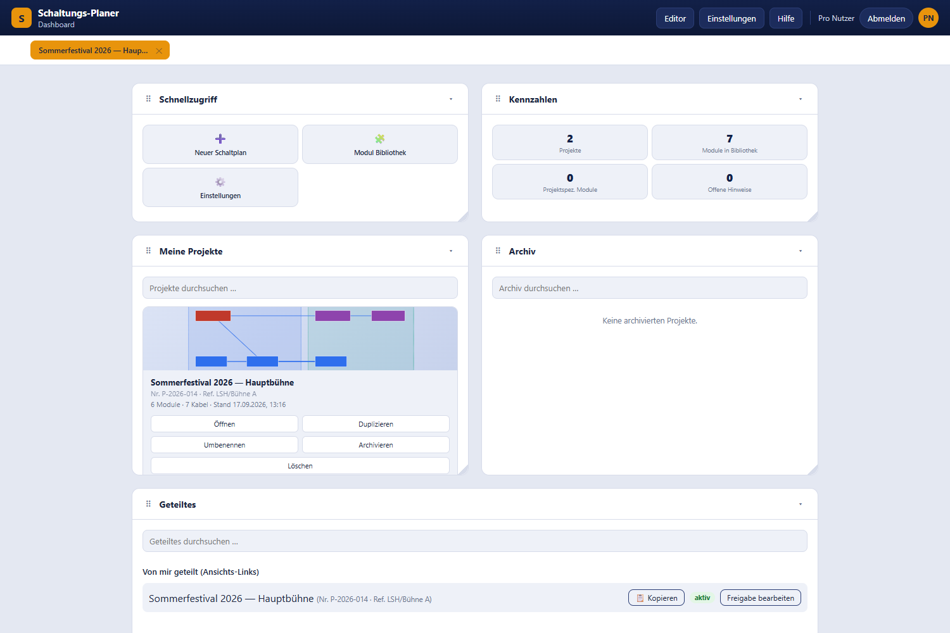
Dashboard with the widgets Quick access, Key figures, My projects, Archive and Shared

3.1 Header bar
Element | Effect
Editor | Opens the most recently edited project. Only appears if there is one.
Settings | Opens the settings.
Help | Opens the online version of this manual.
Avatar | Opens the user menu.
Log out | Ends the session.

3.2 Open tabs
Below the header sits a tab strip listing the projects most recently opened in the editor (up to ten). A click reopens the project; the “✕” only removes the tab — the project itself is untouched. The strip is stored locally in the browser only.

3.3 Arranging widgets
All dashboard tiles are widgets in a twelve-column grid:
- Move: drag the “⠿” handle.
- Resize: drag the handle at the bottom right.
- Collapse/expand: click “▾”.
The layout is stored locally in the browser. A preset arrangement applies at first; every change of your own overrides it field by field.

3.4 Widget “Quick access”
Button | Effect
➕ New diagram | Creates a new project (see 3.6).
🧩 Module library | Opens the module library.
⚙️ Settings | Opens the settings.

3.5 Widget “Key figures”
Tile | Meaning
Projects | Number of all your projects, archived ones included.
Modules in library | Number of library modules visible to your account.
Project modules | Total of project-specific module assignments across all your projects (created for instance by import).
Open notices | Placeholder for future notices; currently fixed at 0.

3.6 Creating, opening and managing projects
The “My projects” widget shows one card per project with a thumbnail, name, project number, internal reference and the line “N modules · M cables · Updated …”.
Action | Step | Effect
Create | “➕ New diagram” | Dialogue with Project name, Project number and Internal reference; creates an empty project.
Open | “Open” or double-click the card | Opens the project in the editor.
Duplicate | “Duplicate” | Immediately creates a copy with the suffix “ (Kopie)” (added by the server, in German); number and reference are carried over.
Rename | “Rename” | Dialogue “Edit project” with name, project number and internal reference.
Archive | “Archive” | Moves the project into the “Archive” widget.
Delete | “Delete” | Confirmation “Delete project”; deletes permanently, including all share links.
The search fields filter by name, project number and internal reference. Sorting is always by modification date, most recently changed first.

3.7 Widget “Archive”
Archived projects appear here with the actions “Open”, “Restore” (returns the project to “My projects”) and “Delete”.

3.8 Widget “Shared”
Two sections:
- “Shared with me” — projects you have been invited to, each with the assigned role and an “Open” button.
- “Shared by me (view links)” — all share links you have created, with the status active, expired or revoked. Via “Edit share link” you can change the role, expiry date and password or delete the share — identical to the sharing dialogue in the editor. “Show QR code” and “📋 Copy” are available here too.

3.9 User menu
Clicking your avatar at the top right opens the menu:
Entry | Effect
🏠 Back to dashboard | Only visible outside the dashboard.
👤 Open profile | Opens the PM Suite profile in a new tab.
📊 Status | Opens the status page.
🚪 Log out | Ends the session.

3.10 Version banner
When a new version of the planner has been installed, the banner “🔴 New version available.” appears with the buttons “Later” (hide the banner) and “Update now” (saves and reloads the page).
Only signed-in people whose session started with the previous version see the banner. Anyone who signs in after the update already works with the new version and gets no notice; the banner never appears on the public view or before signing in. After “Update now” it stays hidden for that version.

4. The editor at a glance
The editor is the actual drawing surface. It consists of the toolbar at the top, the module panel on the left, the canvas in the middle and the canvas bar at the bottom.
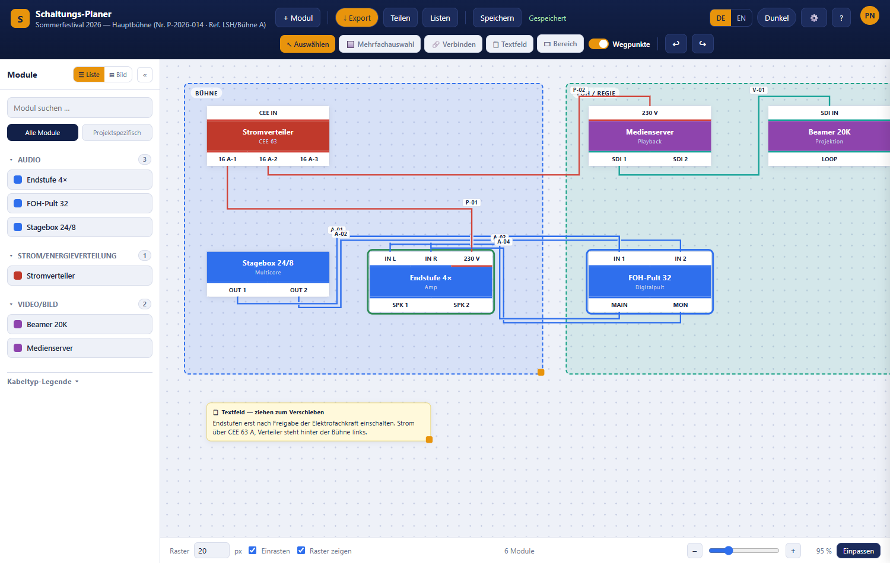
Editor with toolbar, module panel, canvas and a finished example plan

4.1 Toolbar
Toolbar of the editor
Button | Effect | Chapter
↖ Select | Select and move modules; dragging on empty canvas pans the view. | 5.2
🔲 Multi-select | Drag a frame around several modules. | 5.3
🔗 Connect | Draw cables between inputs and outputs. | 6
🗒 Text field | Create a text field on the canvas. | 7.2
▭ Area | Drag out a coloured area. | 7.1
Waypoints | Shows or hides the handles on cables. The routing itself is kept either way. Default: on. | 6.4
↩ / ↪ | Undo and redo. | 4.5
+ Module | Opens the module editor and places the new module directly in the plan. | 8
Import | Opens the import chooser. Currently not visible for every account, see 9. | 9
↓ Export | Opens the export dialogue. | 11
Share | Opens sharing and collaboration. | 12
Lists | Opens pack list and connection list. | 10
Save | Saves immediately without waiting for autosave. | 4.4
Status display | Shows “Saved”, “Saving …” or “Error while saving”. | 4.4
DE / EN | Switches the interface language. The choice applies to every page and is stored as a setting. | 13.2
Dark / Light | Switches the colour scheme. | 13.1
⚙️ | Opens the settings. | 13
? | Opens the online help. | —
Avatar | Opens the user menu. | 3.9
The top left shows the project name, project number and internal reference — the same text also appears in the browser tab. DE / EN, Dark / Light, ⚙️ and ? sit right-aligned, directly to the left of the avatar.

4.2 Module panel
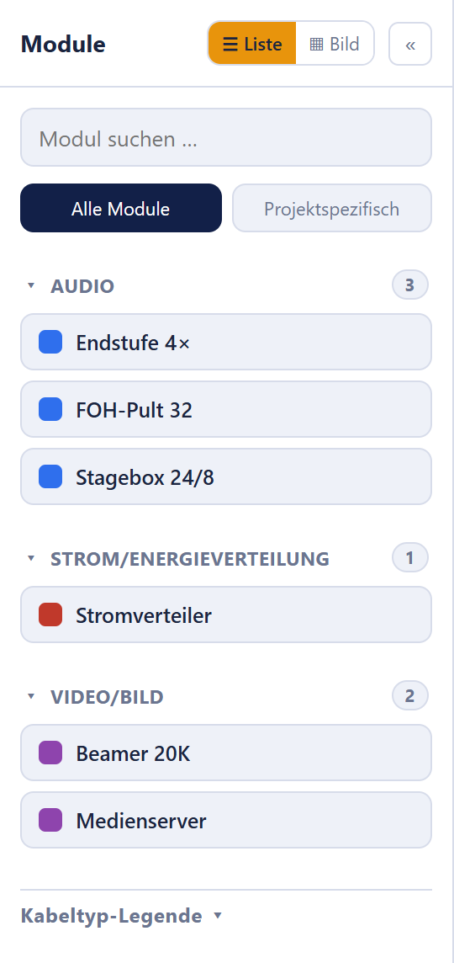
Module panel with search, scope switch and modules grouped by category
Element | Effect
☰ List / ▦ Grid | Switches between list and tile view. In tile view the photo stored in the module editor is used as the tile background.
« / » | Collapses or expands the panel.
“Search modules …” | Filters live by module title and category.
All modules | Shows the whole visible library.
Project-specific | Shows only modules already used in or assigned to this project — for instance after an import.
Category headers | A click folds a category open or shut; the number on the right gives the module count.
Cable type legend ▾ | Shows the colour legend of all cable types.
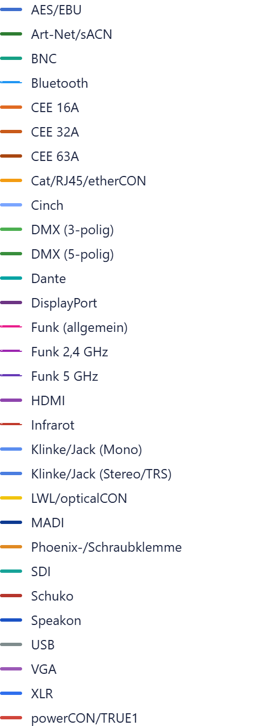
Cable type legend in the module panel
If the panel is empty you will see either “No modules found.” or “No project-specific modules yet — place modules or import a pack list.”

4.3 Canvas, grid and zoom
Bar at the bottom edge with grid size, snapping, grid display, module counter and zoom
Control | Default | Effect
Grid (in px) | 20 | Spacing of the snapping grid, 5 to 200 px in steps of 5.
Snap | on | Positions snap to the grid. Switched off, positioning is pixel-exact.
Show grid | on | Shows or hides the grid dots. This does not affect snapping.
Module counter | — | Shows the number of placed modules.
– / slider / + | 100 % | Zoom between 25 % and 300 %.
Fit | — | Zooms and pans so the entire plan is visible.
Further gestures:
- The mouse wheel zooms continuously; the point under the cursor stays put.
- Dragging with the middle mouse button pans the view.
- Dragging with the left mouse button on empty canvas pans as well, provided the “↖ Select” tool is active.
- The first time a project is opened the editor fits the view automatically. After that the last saved zoom applies.
- The canvas grows with its content; it is at least 4000 × 3000 px.

4.4 Saving and autosave
The planner saves by itself. How it does so is governed by the autosave setting:
- After every change (default): about a second after the last change.
- At interval: every 1 to 60 minutes, 5 minutes by default.
The display next to “Save” shows the current state. If it reads “Error while saving”, the state was not saved — usually because of a broken connection or missing edit rights. Check the connection and click “Save” again; only close the window afterwards.
Note: When several people edit at once, the planner merges their changes on saving. See Collaborating.

4.5 Undo and redo
- ↩ Undo — Ctrl+Z
- ↪ Redo — Ctrl+Y or Ctrl+Shift+Z
All plan changes are covered: placing, moving, deleting and duplicating modules, cables and waypoints, areas and text fields, grid size, zoom and colour scheme. Up to 100 steps are available. Changes in quick succession — typing in a text field, for example — are merged into a single step.
Undo and redo only affect your own steps. Changes that other people have saved in the meantime are kept.
While you are typing in an input field the shortcuts do not apply; normal browser text editing takes over there.

5. Placing and editing modules

5.1 Placing modules
Two ways from the module panel:
- Drag and drop: drag a module from the panel to the desired spot on the canvas.
- Double-click an entry in the panel: the module appears near the centre of the screen.
A device that does not exist yet is created with “+ Module” — see module editor.

5.2 Selecting and moving
- Select: click a module. The cables attached to it are highlighted, all others dimmed.
- Move: drag the module with the left mouse button held down. Cables follow live.
- Deselect: Esc or a click on empty canvas.

5.3 Multiple selection
- Activate “🔲 Multi-select” and drag a frame. Every module the frame touches is selected; it does not have to be fully enclosed. On release the tool automatically switches back to “↖ Select” and the selection is kept.
- Holding Shift or Ctrl makes the frame extend an existing selection instead of replacing it.
- Shift- or Ctrl-clicking a single module adds it to the selection or removes it.
- Ctrl+A selects all modules.
- Dragging one selected module moves all selected ones together.
- Del deletes all selected modules together with their cables.

5.4 Module context menu
Right-clicking a module (long press on touch devices) opens the context menu.
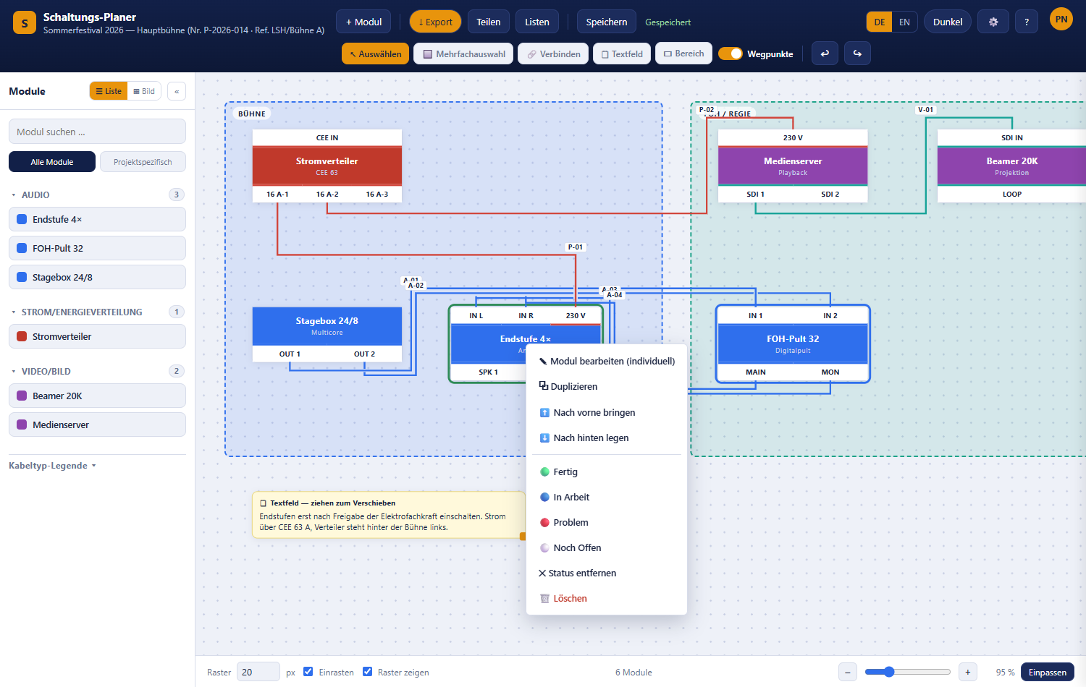
Module context menu with editing, duplicating, layering and status entries
Entry | Effect
✎ Edit module (individually) | Opens the module editor with a private copy — see 5.6.
⧉ Duplicate | Creates a second placement of the same module, offset by 30 px.
⬆ Bring to front | Puts the module in front of all others.
⬇ Send to back | Puts it behind all others.
🟢 Done / 🔵 In progress / 🔴 Problem / ⚪ Still open | Sets the work status.
✕ Remove status | Only shown when a status is already set.
🖼 Show photos | Only shown when the module has at least one photo (see the module editor) — opens a full-screen gallery with previous/next navigation. Also appears for pure viewers of a share link, who otherwise see no context menu at all.
🗑 Delete | Deletes exactly this module and its cables.
Careful: “🗑 Delete” in the context menu deletes only the module you right-clicked — not an existing multiple selection. For several modules use the Del key.

5.5 Setting the work status
Modules and cables can carry an assembly status, shown as a coloured halo:
Status | Colour | Typical meaning
🟢 Done | green | Wired and checked
🔵 In progress | blue | Currently being set up
🔴 Problem | red | Faulty, missing or open question
⚪ Still open | grey | Not started yet
The status may also be set by people with the Technician role, who otherwise cannot change the plan — see roles and permissions.

5.6 Adapting a single module individually
Every placement of a module refers to the same library entry. To change an already placed device without affecting all other occurrences, use “✎ Edit module (individually)”:
- The module editor opens with a copy of the module data.
- The title automatically receives a variant number, for example “Stromverteiler (2)”.
- Saving via “Save individually” creates a new library module and only the edited node is switched over to it.
Other placements of the original module — in other projects too — stay unchanged. Over a public share link this entry is not available, because it requires a signed-in session.

5.7 Free limits
The Free account type has the following limits:
Limit | Value
Own diagrams in use | 1
Own diagrams in the archive | 1
Modules per project | 10
Areas per project | 2
When a limit is reached the notice “Free limit reached” appears. To create a new diagram (also by duplicating or restoring one from the archive), archive or delete the existing one first; if the archive is occupied, delete the archived diagram before archiving the next one. Diagrams that others share with you do not count. Existing diagrams are kept even if there are more than allowed — only creating further ones is blocked. For modules and areas, what counts is always the account type of the project owner, not that of the person currently editing. Your own account type is shown on the status page.

6. Connecting — drawing and routing cables

6.1 Creating a connection
There are two equivalent ways:
- Click – click: activate “🔗 Connect”, click the source field (a dashed preview line follows the cursor), then click the target field.
- Drag: drag straight from an input or output field to the target field and release there. This works regardless of the tool currently active.
Esc cancels a connection in progress, as does switching tools.
Clicking a field that carries exactly one connection releases that connection so it can be redrawn immediately.

6.2 Which fields can be connected
Rule | Meaning
Different modules | Two fields of the same module cannot be connected.
Direction | One side must be an output (or a combined field), the other an input.
Same cable type | Both fields must have the same cable type.
Inputs single | An input carries at most one connection.
Outputs multiple | One output may feed several inputs.
If a connection is not allowed there is no text message: the field flashes red briefly. Usually the cause is a differing cable type or an input that is already taken.

6.3 Cable routing
Cables run at right angles only. They leave and enter perpendicular to the module edge and automatically route around other modules when the direct path would run through a device. Cables that would run exactly on top of each other are offset slightly so they stay distinguishable.

6.4 Waypoints
Waypoints let you determine a cable’s route by hand.
Action | Gesture
Add a waypoint | Double-click the cable — or simply grab and drag the cable at the desired spot; the waypoint is created automatically.
Move a waypoint | Drag the handle (small circle).
Delete a waypoint | Double-click the handle, or right-click → “🗑 Delete waypoint”.
Show/hide handles | The “Waypoints” switch in the toolbar.
Automatically placed corners have handles too; they have a dashed outline, fixed waypoints a solid one. Dragging a dashed corner turns it into a fixed waypoint — a plain click changes nothing. Double-clicking a dashed corner deletes the nearest fixed waypoint that forces this corner; the cable then reroutes. Positions snap to the grid.
The “Waypoints” switch hides the handles only, not the routing — for a tidy look at the finished plan.

6.5 Line hops at crossings
Where two unconnected cables cross, a small gap is left automatically: the most recently edited cable “hops” over the other. The gap width follows the zoom level so it always looks the same on screen. No gap is ever placed right at a connector field.
The feature can be switched off in settings under “Line jumps at crossings”.

6.6 Selecting, labelling and deleting cables
Clicking a cable selects it and opens the cable inspector above the canvas.
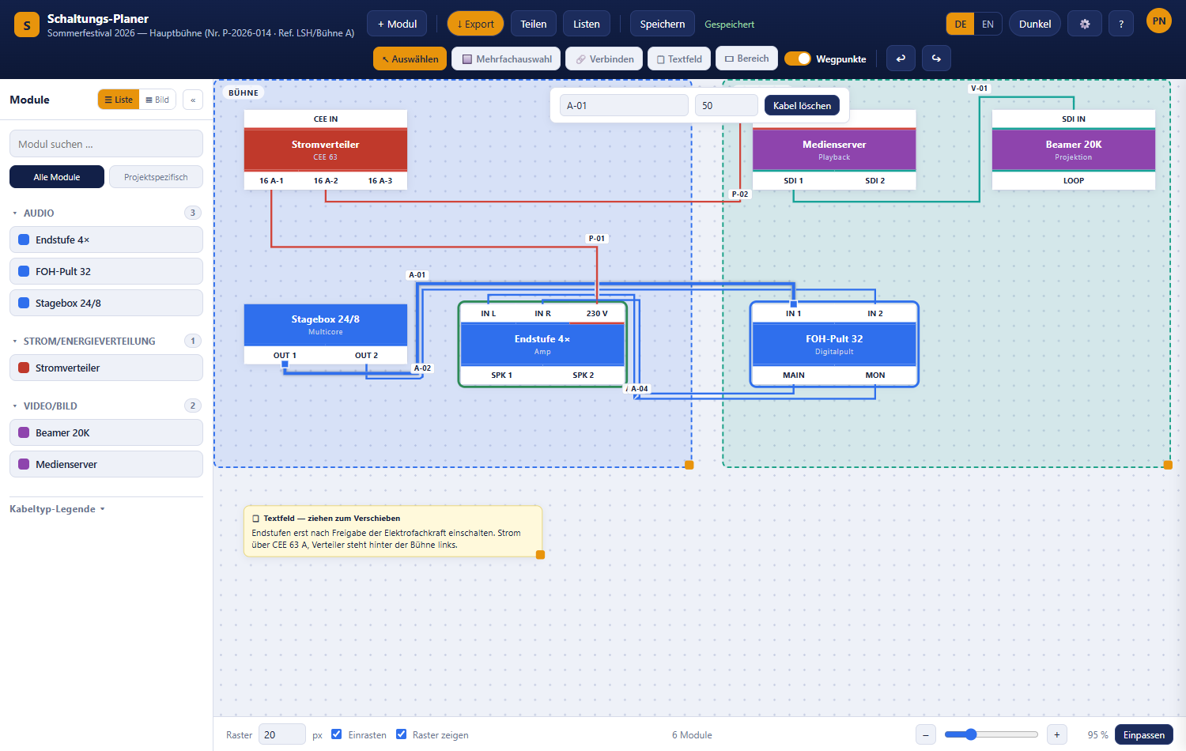
Selected cable with the inspector for label and length
Element | Effect
Cable label | Free designation, for example “A-01”. Appears as a tag on the cable and in the connection list.
Length (m) | Cable length, for example “20”. Also appears in the connection list.
Delete cable | Removes the connection immediately.
Further options:
- Right-clicking a cable opens the context menu with “✎ Edit (label & length)”, the status entries and “🗑 Delete connection”.
- The label can be dragged freely if its default position is awkward.
- While a cable is selected, square handles appear at its start and end. Dragging one of them onto another compatible field moves the cable there.

6.7 Cable types
Every input and output field carries a cable type; it determines the colour and line style of the connection and decides which fields can be connected at all. Wireless types are drawn as dashed lines.
The full list is in Appendix A. Custom types are created in settings.
Cable type names follow the language: with EN selected, the cable type legend, the connection list and the selection in the module editor show the English name where one is maintained — otherwise the German one.
For people with colour vision deficiency a colour profile can be chosen in settings; cable colours then switch to a well-distinguishable palette.

7. Areas and text fields

7.1 Areas
Areas are coloured surfaces in the background used to mark zones such as “stage”, “FOH/control” or “backstage”.
Action | Step
Create | Activate “▭ Area” and drag a frame. Without dragging you get an area of 240 × 160 px; the minimum size is 60 × 60 px.
Move | Drag the title bar.
Resize | Drag the handle at the bottom right.
Title and colour | Double-click the title bar or right-click → “✎ Edit (title & color)”.
Duplicate | Right-click → “⧉ Duplicate”.
Delete | Right-click → “🗑 Delete”.
Areas always sit behind the modules and never get in the way. After creating one the tool switches back to “↖ Select” automatically.
The colour dialogue offers 14 predefined colours, the colours you saved most recently, and a free colour field with hex entry and a “+ Save” button.

7.2 Text fields
Text fields hold notes and images — for example set-up instructions, contacts or a photo of the connection situation.
Action | Step
Create | Activate “🗒 Text field” and click the canvas.
Move | Drag the “🗒” symbol in the title row.
Change title and text | Click into the field and type.
Change width | Drag the handle on the right. The height grows with the content automatically.
Change colour | Right-click → “🎨 Change color”.
Insert an image | Drag and drop an image file onto the text field.
Duplicate / delete | Right-click → “⧉ Duplicate” or “🗑 Delete”.
Permitted images: JPEG, PNG, WebP and GIF up to 8 MB. SVG is deliberately not allowed because such files can contain their own program code. A file whose content does not match its extension is rejected — see Appendix D.

8. Module editor and module library

8.1 The module editor
The module editor describes a device: name, appearance and, above all, the inputs and outputs with their cable types.
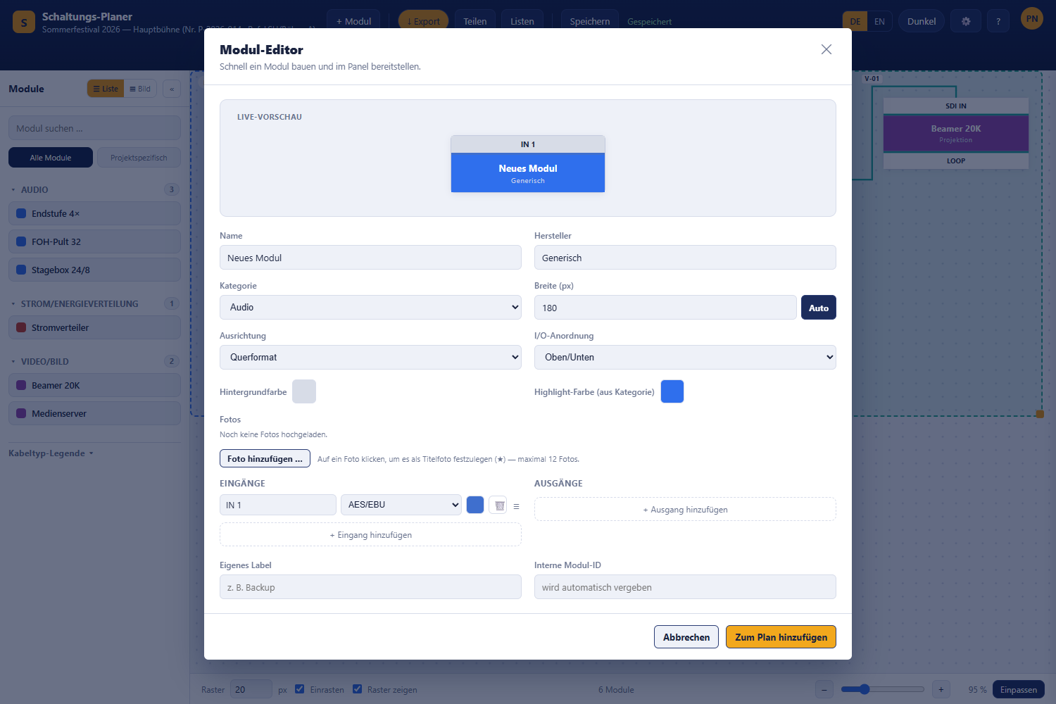
Module editor with live preview, master data and input/output rows
It can be opened in three ways:
Way | Save button | Result
“+ Module” in the editor | “Add to plan” | New library module, placed in the plan straight away.
“+ New module” in the library | “Create module” | New library module.
“✎ Edit module (individually)” in the context menu | “Save individually” | Private copy for this one placement, see 5.6.

Fields
Field | Meaning
Name | Mandatory. Without a name you get “Missing information — Please enter a name.”
Manufacturer | Appears in small type under the name and in the pack list.
Category | Determines the grouping in the module panel. See Appendix B.
Width (px) | 60 to 1600 px. “Auto” calculates the width so that every input and output has room for its label (widest connector × number of connectors); with “Automatic (rotate if too long)” it uses horizontal labels as long as they fit into 1600 px, otherwise vertical ones. If the module is wider than the dialog, the preview scrolls sideways.
Orientation | Landscape or Portrait.
I/O placement | Top/bottom or Left/right — where the connector fields sit.
Input/output labels | Horizontal (default), Vertical (rotated 90°) or Automatic (rotate if too long). Vertical labels stand upright, read from bottom to top and are centred in their field — long names stay readable with many connectors instead of being cut off with “…”. The row grows to the longest name (at most 140 px, beyond that it is shortened again). “Automatic” only rotates the row (inputs or outputs) in which a name does not fit horizontally. The field only appears for Landscape with Top/bottom — with Left/right and in Portrait every connector already has its own line. Also applies in the share view and in export.
Background color | Fill colour of the module body.
Highlight color (from category) | Colour of the title bar. Not freely selectable per module — it comes from the category and follows automatically whenever that category’s colour is changed in Settings.
Photos | “Add photo …” uploads multiple photos (up to 12, downscaled automatically). Clicking a photo marks it as the cover photo (★) — shown as the icon on the module node in the plan and as the tile image in the library. All photos can later be viewed as a gallery via “🖼 Show photos” in the context menu — even by viewers of a share link.
Custom label | Free additional designation.
Internal module ID | Optional. Left empty, the system assigns an ID. The ID serves as the unique key for import.

Inputs and outputs
Per column, “+ Add input” and “+ Add output” create a new row. Each row consists of:
- Name — e.g. “IN 1”, “MAIN”, “230 V”. New fields are numbered automatically.
- Cable type — determines colour and connectability, see 6.2. You can type into the field: the list then shows only matching cable types (e.g. “dmx” → “DMX (3-pin)”, “DMX (5-pin)”). Accept with the arrow keys and Enter or by clicking; Esc discards the input.
- Colour swatch — optionally overrides the cable type colour.
- 🗑 — deletes the row.
- ≡ — drag handle for reordering.
The live preview at the top shows the module exactly as it will look in the plan.

8.2 Module library
The separate page “My modules & library” (dashboard → “🧩 Module library”) lists all visible modules.
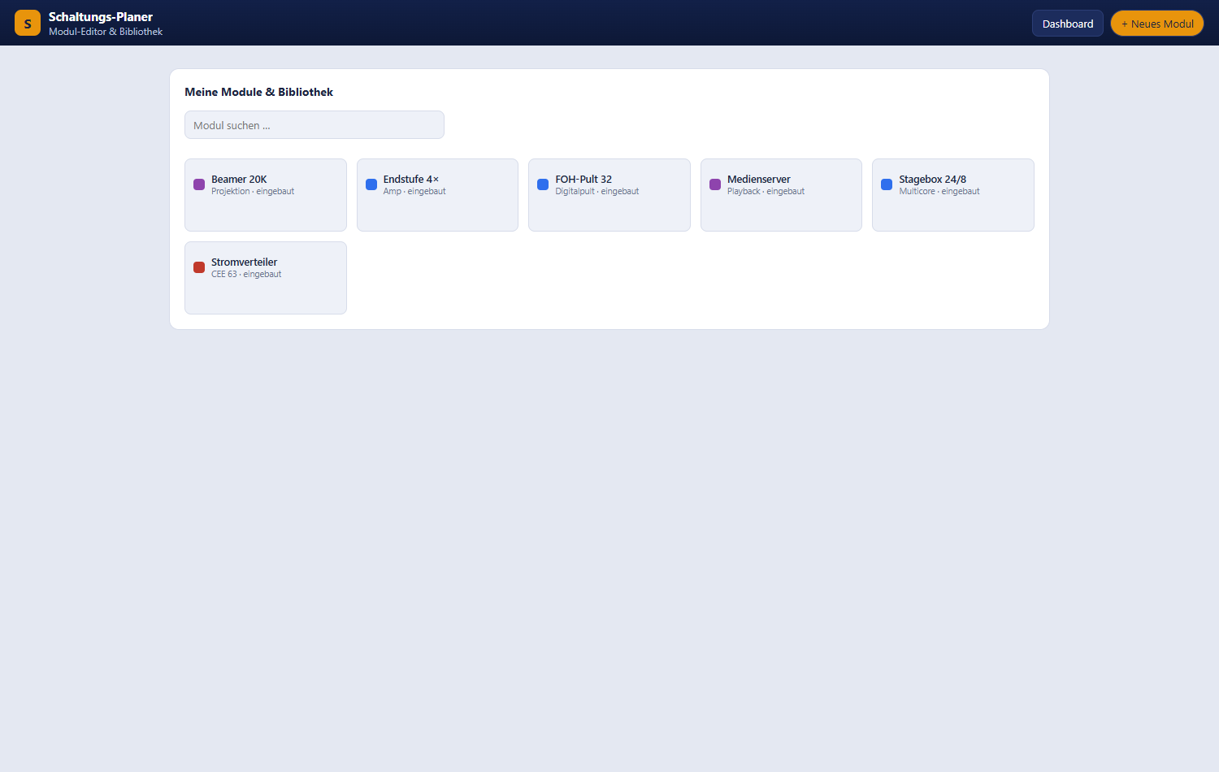
Module library with search field and module tiles
Element | Effect
“Search modules …” | Filters by title and manufacturer.
+ New module | Opens the module editor.
Edit | Only for your own modules.
Delete | Only for your own modules, with a confirmation.
Built-in and globally released modules cannot be edited — they are maintained centrally. To adapt such a module, use “✎ Edit module (individually)” in the context menu, which gives you your own copy.

8.3 Module visibility
Visibility | Who sees the module
Global | Everyone. Released centrally.
Customer | Only the account that owns it. All self-created and imported modules start here.
In addition there is the project-specific assignment: through import or by placing them, modules are assigned to a single project and can be filtered in the module panel via “Project-specific”. This does not change the visibility of the module itself.

9. Importing material, pack and plan lists
The “Import” button in the toolbar opens the choice between two kinds of import.
Note: Import is currently being trialled and is not yet enabled for every account. If it is not enabled for yours, the “Import” button is missing and an import attempt ends with the server message “Der Import ist derzeit nicht freigegeben.” (import is currently not enabled)
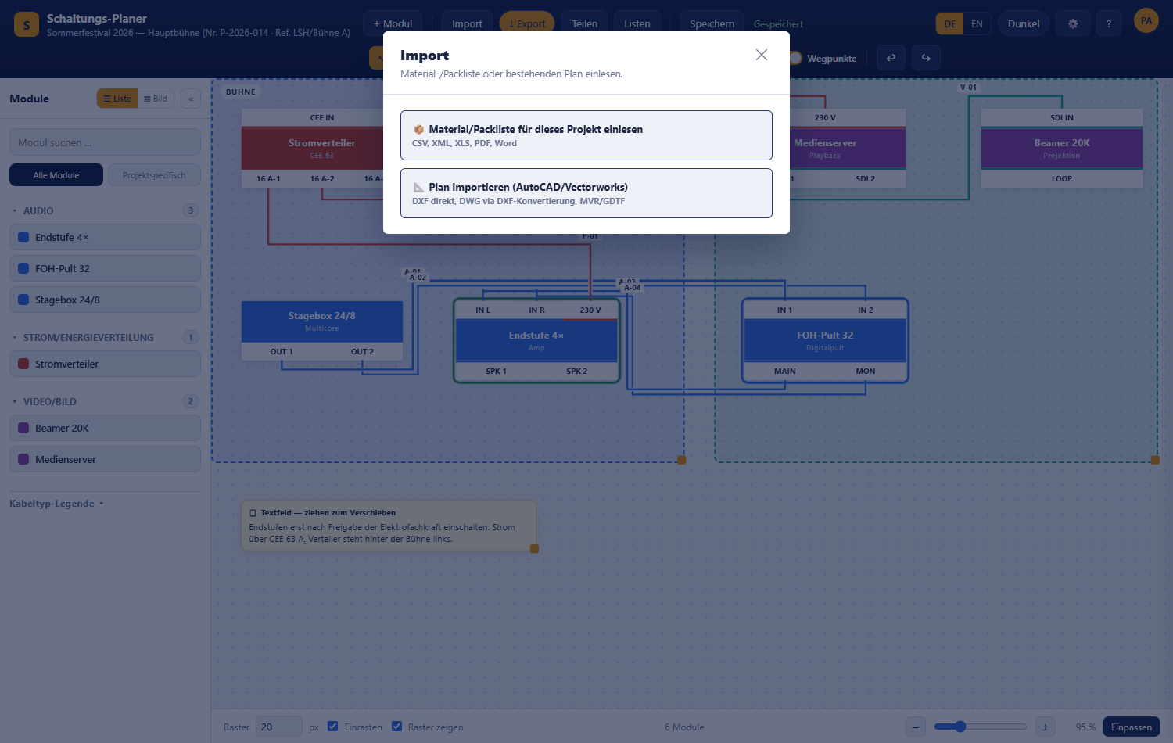
Import chooser with material/pack list and plan import

9.1 Material and pack lists
“📦 Import material/pack list for this project” takes a device list into the current project.

Supported formats
Format | Expected structure | Limits
CSV / TSV / TXT | First row is the header. The separator (,, ;, tab) is detected automatically. | —
XLSX / XLS | First worksheet, first row as header. | Covers common files but is not a full Office parser.
DOCX / DOC | The largest table in the document, first row as header. | Without a table the import fails.
XML | The most frequently repeated node group is read as the set of rows. | Files with a DOCTYPE declaration are rejected for security reasons.
JSON | List of objects or {"items":[…]}. | —
Text-based PDF | Text extraction, columns split on runs of spaces. | Scanned or encrypted PDFs yield no text.
The maximum file size is 20 MB.

Recognised columns
Column headers are detected automatically; case does not matter and partial matches are enough:
Content | Recognised headers
Name (mandatory) | Name, Bezeichnung, Artikel, Gerät, Titel, Device, Modul
Manufacturer | Hersteller, Marke, Manufacturer, Brand
Category | Kategorie, Category, Typ
Internal ID | Artikelnummer, SKU, ID, Modul-ID, internal_id
Quantity | Menge, Anzahl, Stück, Qty, Quantity (default 1)
If no recognisable name column is present, the import stops with a clear message — see Appendix D.

How matching works
- First the internal module ID is looked up.
- Otherwise the title and, if given, the manufacturer.
- Match: the existing library module is assigned to the project with the stated quantity.
- No match: a new module visible only to your own account is created automatically — without inputs and outputs. These have to be added once in the module editor before the device can be connected.
At the end the dialogue reports “Import complete” with the summary “n matches · m new modules · k total”, then the project reloads.
There is no manual column mapping — recognition is fully automatic. If it does not fit, adjust the header row of the source file to the designations listed above.

9.2 Plan import (DXF and MVR)
“📐 Import plan (AutoCAD/Vectorworks)” takes device positions from an existing plan.
Format | What is taken over
DXF | Block references are matched against the library by name and placed as modules. Texts become text fields. Blocks that cannot be matched are inserted as a note text field. Pure geometry (lines, polylines, circles) is not taken over.
MVR (GDTF) | Fixture entries are matched by name or GDTF designation and placed as modules. Without a match a new module in the “Licht” category is created automatically.
The result reports “n imported · m unclear/new · k geometry items not imported”.
DWG and .vwx cannot be read directly — both formats are proprietary. The planner says so and names the route: export from AutoCAD as DXF, from Vectorworks as MVR (devices and positions) or DXF (geometry).
Plan import is reserved for the project owner; invited editors can import material lists but not plans.

10. Lists — pack list and connection list
The “Lists” button opens a panel on the right with two tabs. The lists update automatically whenever the plan changes.

10.1 Pack list
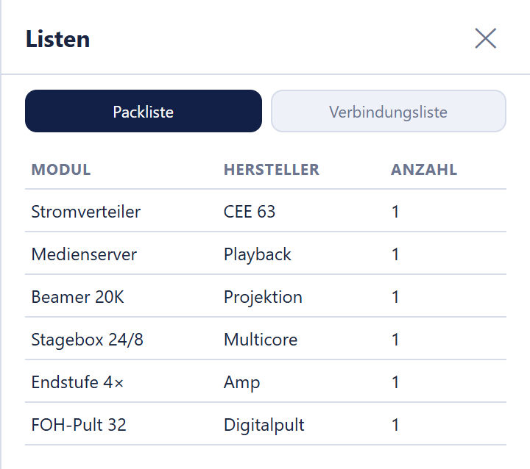
Pack list with module, manufacturer and quantity
The pack list summarises all placed modules and counts identical devices together:
Column | Content
Module | Module title from the library
Manufacturer | Manufacturer from the module editor
Quantity | Number of placements in the plan
If the plan is empty you see “No modules in the plan yet.”

10.2 Connection list
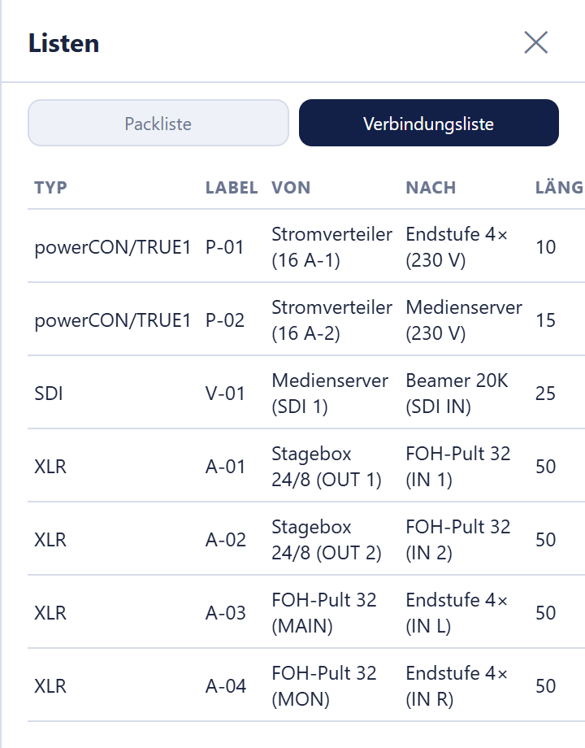
Connection list with type, label, from, to and length
The connection list shows every cable individually, sorted by cable type:
Column | Content
Type | Name of the cable type
Label | Designation from the cable inspector
From | Source module with connector field, e.g. “FOH-Pult 32 (MAIN)”
To | Target module with connector field
Length | Length in metres; “—” if not stated
If nothing is connected yet you see “No cables in the plan yet.”

10.3 Outputting lists
Button | Result
CSV export | packliste.csv or verbindungsliste.csv, semicolon-separated and marked so that special characters display correctly in Excel.
PDF export | packliste.pdf or verbindungsliste.pdf with project name, creation date and table header; generated on the server.
If a download fails, the planner reports “Export failed.” Check the connection and repeat.

11. Export
“↓ Export” opens the dialogue “Export plan”. The entire plan is exported, not just the visible section; waypoint handles never appear in an export.
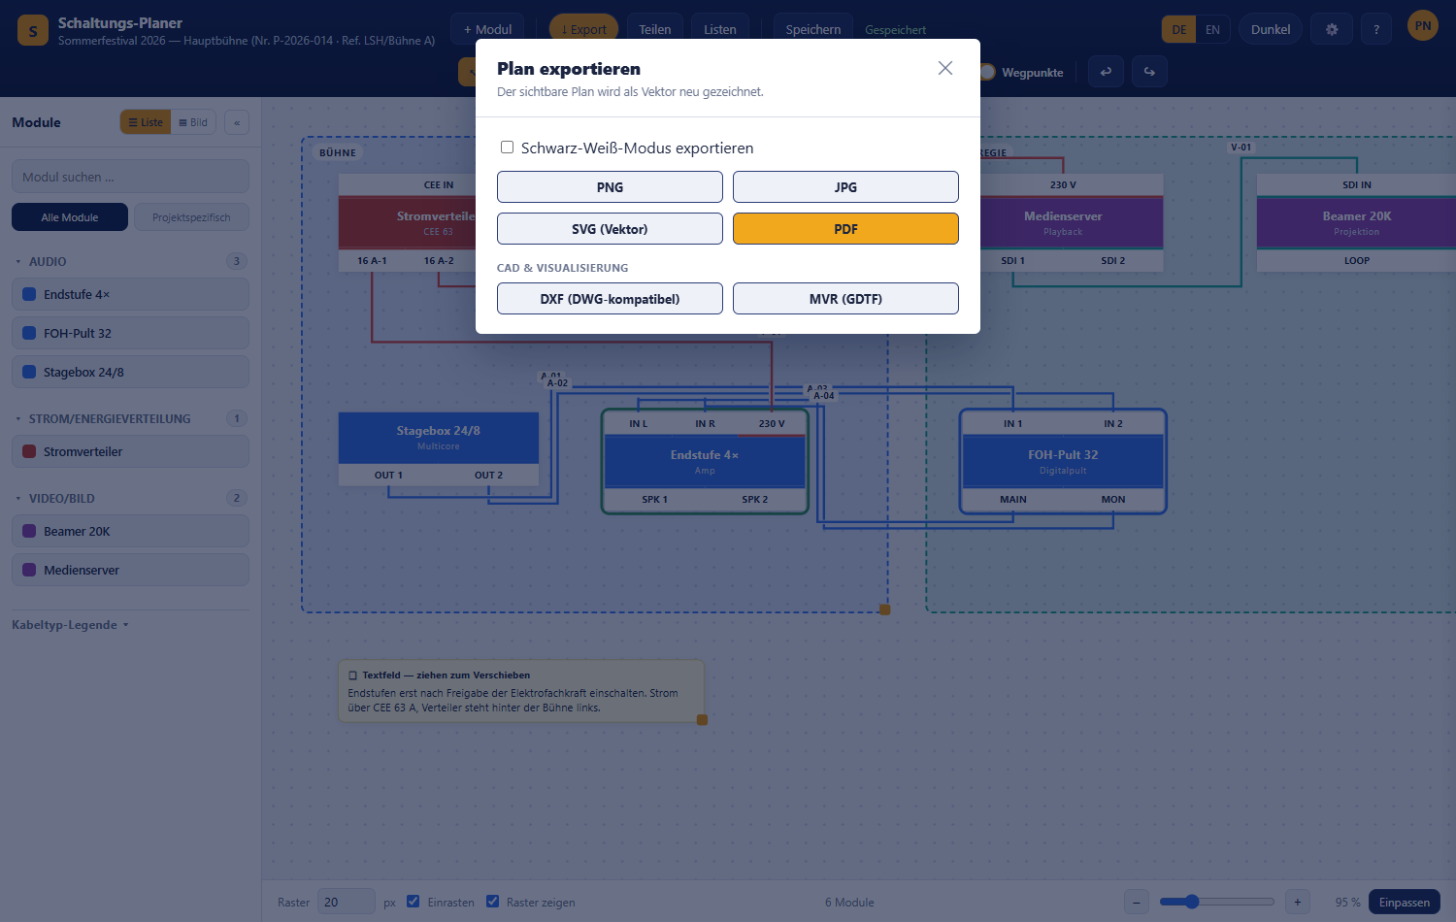
Export dialogue with black-and-white switch, image formats and CAD formats
Format | Kind | Suitable for
PNG | Raster image at double resolution | Presentations, email, chat
JPG | Raster image at double resolution | As PNG, smaller file
SVG (vector) | True vector, redrawn from the plan data | Further work in a graphics program, lossless scaling
PDF | One page, portrait or landscape depending on the aspect ratio | Printing, handing on
DXF (DWG-compatible) | CAD file with the layers MODULE, KABEL, BEREICH, TEXT | Opens in any DWG-capable CAD program
MVR (GDTF) | Container with module positions as fixtures | Handover to Vectorworks and GDTF tools
“Export in black-and-white mode”: the checkbox at the top outputs the plan in grey scale on a white background — for black-and-white printing. PDF exports always use a white background regardless of the colour scheme in use.
MVR requires the project to be saved; otherwise you get “MVR export is only possible after the project has been saved.”
Note: Direct export as binary DWG is not possible because it would require a commercial third-party library. DXF is the open, lossless substitute and is read by AutoCAD and comparable programs without detours.

12. Sharing and collaborating
“Share” opens the dialogue “Share & collaborate”. Only the host — the person who owns the project — can create and manage share links.
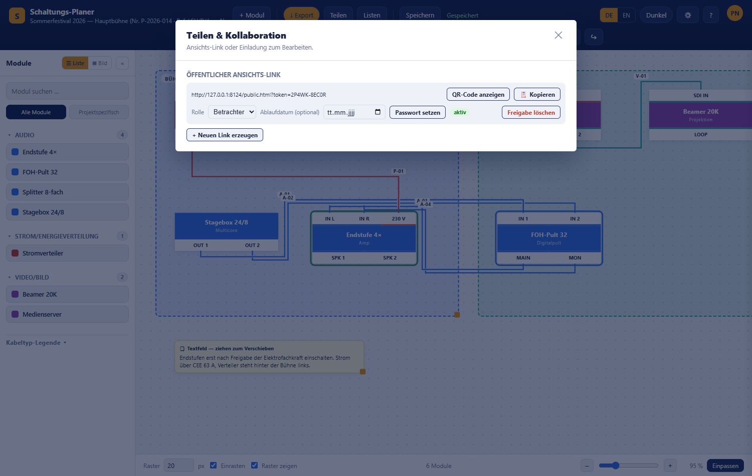
Sharing and collaboration dialogue with the public view link

12.1 Public view link
“+ Create new link” creates an address of the form …/public.html?token=… that works without signing in. Two buttons sit next to the address:
- “Show QR code” opens a window with the link as a QR code. Scanned with the camera of a phone or tablet, it opens the plan directly — handy for technicians on site, for example. The code is generated by the planner itself; the link is not sent to any third-party service.
- “📋 Copy” copies the address to the clipboard.
The link can then be configured in detail:
Setting | Meaning
Role | Viewer, Editor or Technician — determines what visitors may do, see roles.
Expiry date (optional) | Optional expiry date. After it the link is invalid. Empty field = no expiry.
Set password / 🔒 Change password | Protects the link with an additional password.
Remove password | Removes the password protection.
Delete share link | Invalidates the link immediately (with a confirmation).
Changes made by visitors of a link with the role Editor or Technician are saved directly to the project and appear for the host and everyone else involved.
The status of a link is shown as active, expired or deleted. All your links are also listed on the dashboard under “Shared”.

12.2 Collaborating
When several people work on a project at the same time:
- The avatars of everyone present appear at the top right with name and role.
- The other people’s cursors are visible on the canvas with name tags.
- The planner synchronises about every 2 seconds. When someone else saves, your editor reloads the new state automatically — including changes made via a share link.
- Closing the window removes your presence immediately.
Simultaneous changes are merged. When saving, the planner only applies what you yourself changed since the last synchronisation; other people’s changes are kept. If, for example, an editor sets the status of one module while the host moves another, both changes remain. In detail:
Situation | Result
Different objects, or different properties of the same object, changed (e.g. status and position) | Both changes are kept.
The same property of the same object changed differently | The value saved last applies.
An object is deleted while someone else changes it | The object stays deleted.
New modules, cables, areas or text fields on both sides | All of them are kept.
Undo and redo only reverse your own steps.

13. Settings
Settings (“⚙️” in the editor or “Settings” on the dashboard) apply per person, not per project. The navigation on the left jumps to the individual sections.
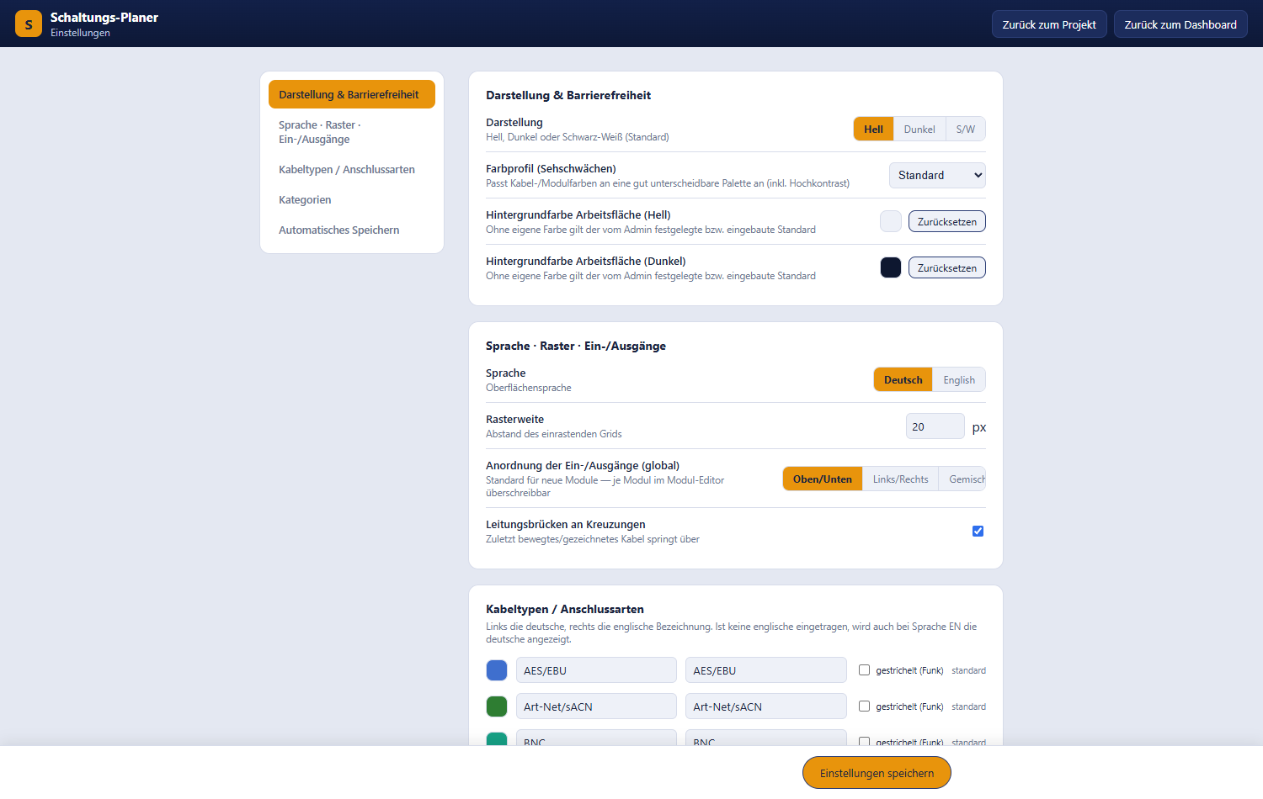
Settings page with appearance and accessibility

13.1 Appearance and accessibility
Setting | Values | Effect
Appearance | Light, Dark, B/W | Colour scheme of the entire interface.
Color profile (color vision deficiency) | Default, Deuteranopia, Protanopia, Tritanopia, High contrast | Switches cable and module colours to a well-distinguishable palette.
Canvas background color (light) | Colour picker | Your own canvas colour in the light scheme. “Reset” restores the preset default.
Canvas background color (dark) | Colour picker | The same for the dark scheme.
Both background colours are saved immediately, not only via “Save settings”.
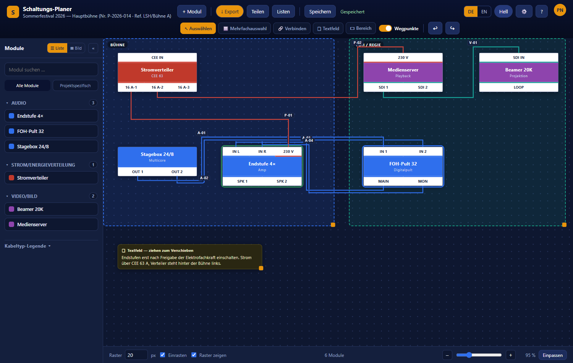
Editor in the dark colour scheme

13.2 Language, grid, inputs and outputs
Setting | Values | Default
Language | Deutsch, English | Deutsch
Grid size | 5 to 200 px | 20 px
Input/output placement (global) | Top/bottom, Left/right, Mixed | Top/bottom
Line jumps at crossings | on / off | on
The language applies to the entire interface: dashboard, editor, settings, module library and module editor, dialogs and messages, and the lists including their PDF and CSV versions. After “Save settings” the page switches immediately; all other pages then open in the chosen language. The DE / EN switch in the editor changes the same setting. A share link shows the language last chosen in the project. Not translated are your own content (project, module, connector and category names), messages from the server, and the legal notice, privacy policy and terms of use.
The arrangement is the default for new modules; it can be overridden per module in the module editor. For line hops see 6.5.
The DE / EN switch in the editor applies to that project; the setting here is your personal starting value.

13.3 Cable types and connector kinds
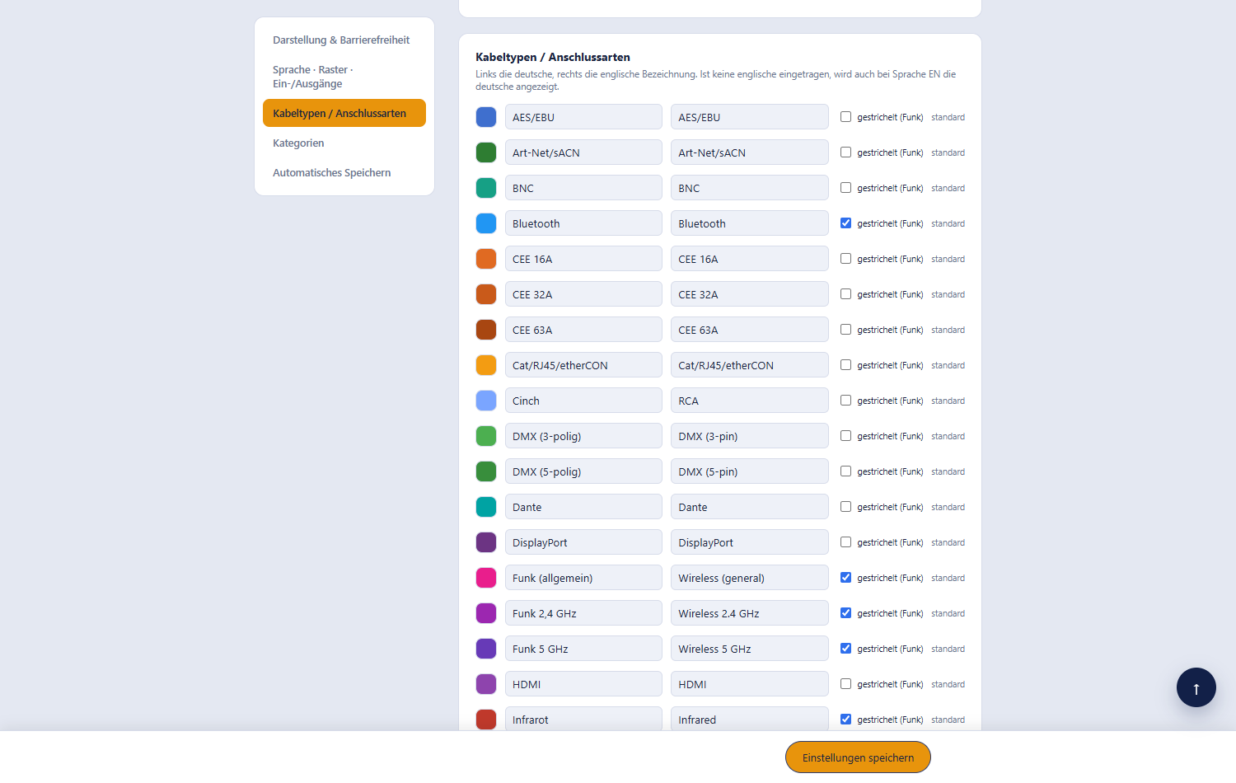
Cable type settings with colour, name and dashed display
Here you can adjust the colour, name and the “dashed (wireless)” option of all cable types. Each row has two name fields: the German name on the left, the English name on the right. The English name is shown when EN is selected in the editor; if the field is empty, the German name is used there too. Changes are saved automatically.
Use “New cable type”, optionally “English name (optional)”, pick a colour and click “Add” to create your own.

13.4 Categories
For each category a personal colour can be set; the badge “custom color” shows where that has happened. The names of built-in categories are locked. “New category” and “Add” create your own categories, visible only to your account.

13.5 Autosave
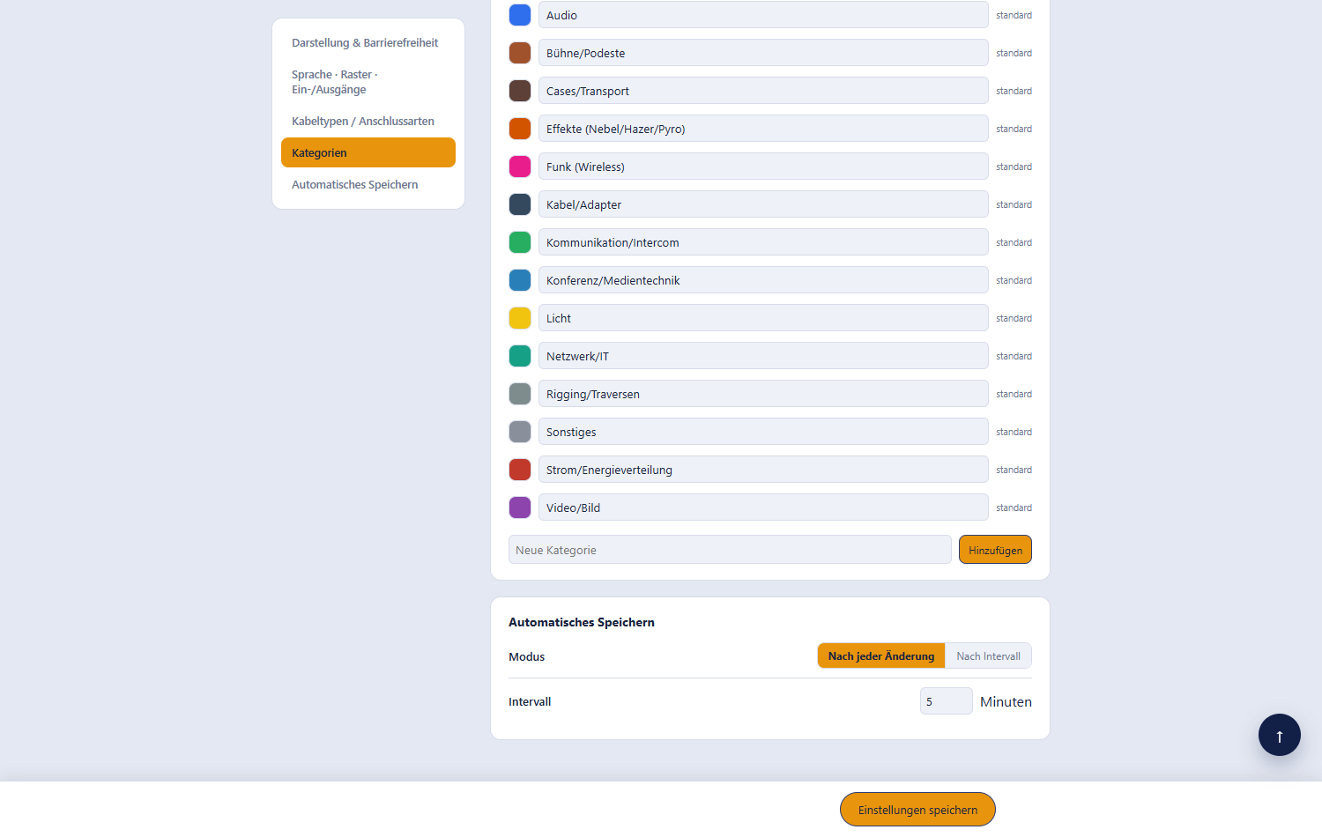
Autosave setting
Setting | Values | Default
Mode | After every change, At interval | After every change
Interval | 1 to 60 minutes | 5 minutes
See also Saving and autosave.

13.6 Saving
“Save settings” in the bottom bar applies the entries; “Saved ✓” appears shortly after. Background colours, cable types and category colours are already saved on selection.

14. Public view
A share link opens the plan without signing in.
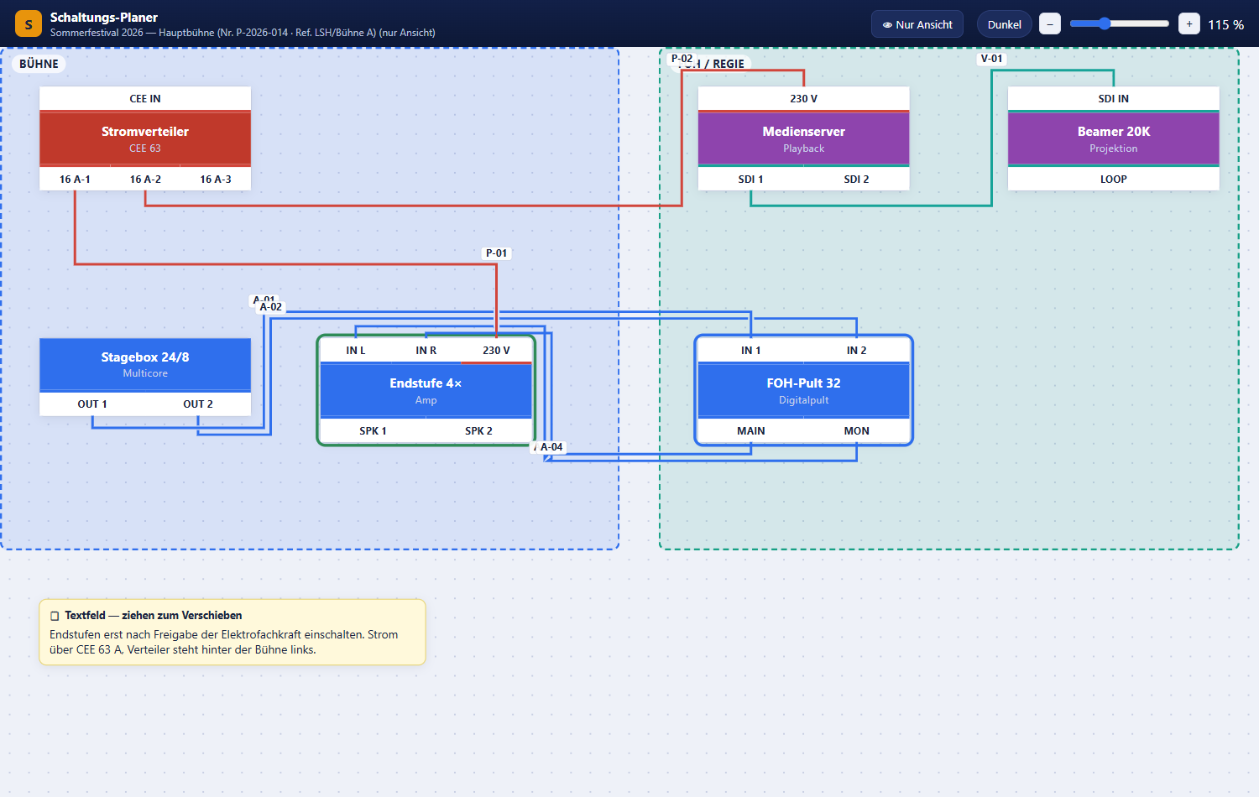
Public view of a shared plan
Visible are the project name, a role badge (“👁 View only”, “✎ Edit” or “🔧 Technician (set status)”), a “Dark / Light” toggle, a zoom control and the complete plan with modules, cables, areas and text fields. The view is fitted automatically on opening and refreshes every three seconds without changing your own viewport.
The “Dark / Light” toggle only affects the person who clicks it: it is remembered locally in that browser, never changes the project itself and stays invisible to anyone else who has the same link open.
Depending on the role of the link:
Role of the link | Possible
Viewer | Viewing, zooming and panning only.
Editor | Additionally moving modules, drawing and labelling cables, changing areas and text fields, setting the status.
Technician | Additionally only setting the status of modules and cables.
Changes made via an editor or technician link are saved and merged with simultaneous changes by others.
Regardless of the role, the public view does not offer: new modules from the library, new areas and text fields, undo/redo, import and export.
Possible messages: “No share token provided.”, “Link ungültig oder widerrufen.” (link invalid or revoked), “Link abgelaufen.” (link expired) and “Password required.” — see Appendix D.

14.1 Status page
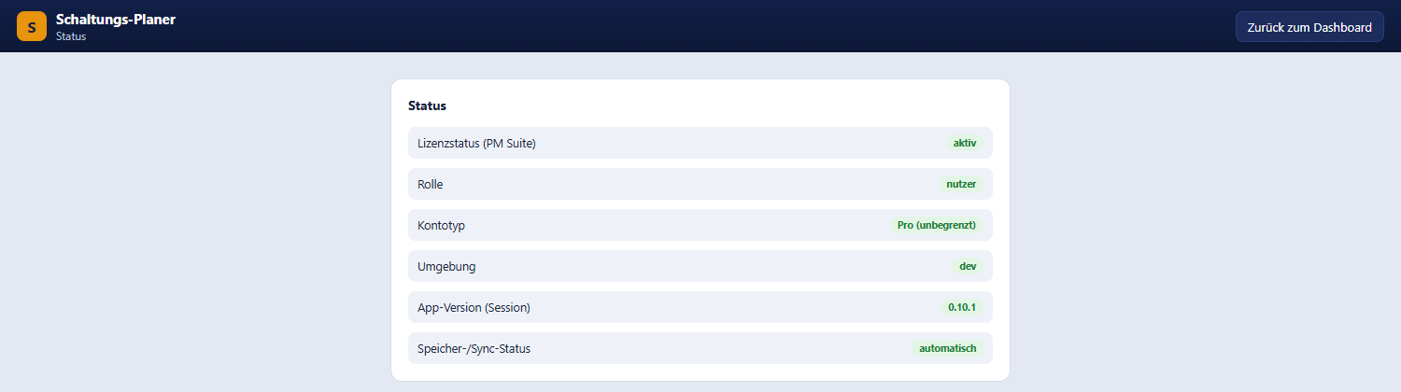
Status page with licence, role, account type, environment and version
Reachable from the user menu → “📊 Status”. It shows the licence status from the PM Suite, your role, the account type (Pro or Free with its limits), the environment, the app version of the running session and the save and sync mode. The page requires a sign-in.

15. Roles and permissions
Three independent levels work together.

15.1 Account type
Account type | Limits
Free | One diagram in use and one in the archive, at most 10 modules and 2 areas per project, see free limits.
Pro | No limits.

15.2 Project role
Role | View | Edit | Set status | Share and invite
Host (owner) | yes | yes | yes | yes
Editor | yes | yes | yes | no
Technician | yes | no | yes | no
Viewer | yes | no | no | no
With restricted rights the editor shows a banner:
- Technician: “Technician mode — editing is not possible; set the status by right-clicking a module/cable.”
- Viewer: “View-only mode (viewer) — changes are not possible.”
Tools, “+ Module”, “Import”, “Share”, “Save” and undo/redo are disabled in that case.

15.3 Role of a share link
A share link carries the same roles Viewer, Editor and Technician with the same rights — except that the permission is attached to the link and no sign-in is needed.

16. Keyboard shortcuts and mouse gestures

16.1 Keyboard
Key | Effect
Del / Backspace | Deletes all selected modules and their cables
Ctrl+A | Selects all modules
Esc | Clears the selection, cancels a connection in progress, closes menus and dialogues
Ctrl+Z | Undo
Ctrl+Y or Ctrl+Shift+Z | Redo
Shift / Ctrl + click | Extends the multiple selection
Enter | Confirms an input dialogue
On macOS, Cmd replaces Ctrl. While typing in an input field the shortcuts do not apply.

16.2 Mouse and touch
Gesture | Effect
Mouse wheel | Zoom around the cursor
Drag with the middle mouse button | Pan the view
Drag with the left mouse button on empty canvas | Pan the view
Drag from the module panel | Place a module
Double-click in the module panel | Place a module at the centre of the screen
Click a cable | Select the cable, open the inspector
Grab and drag a cable | Create a new waypoint and move it
Double-click a cable | Add a waypoint
Double-click a handle | Remove a waypoint
Double-click an area title | Edit title and colour
Right-click | Context menu
Long press (touch) | Context menu

17. Frequently asked questions and troubleshooting
Why can I not change anything? You have been invited as a viewer or technician or you are looking at a public share link. The banner at the top of the editor states the reason.
Two fields will not connect — the field just flashes red. Both fields need the same cable type, and an input must not be taken already. See connection rules.
An imported device has no connectors. Modules created during import come without inputs and outputs. Add them once in the module editor.
I changed one module and suddenly all the others look the same. All placements share the same library entry. For a single change use “✎ Edit module (individually)”, see 5.6.
Can I import or export DWG files? No — DWG is proprietary. Export as DXF from AutoCAD or Vectorworks, or use the planner’s DXF export; DXF is read by DWG-capable programs.
My PDF import finds no text. Scanned or encrypted PDFs contain no readable text. Export the list as CSV, XLSX or XML and import that file.
It says “Error while saving”. The state was not saved. Check the connection and click “Save” again before closing the window. See 4.4.
I am hitting a limit of 10 modules. The project belongs to an account of type Free. See free limits.
Where is my data stored? On the server, in two separate databases — one for sign-in, one for working data. The transfer is encrypted. The planner is a pure website and needs a working connection.
A colleague overwrote my change. Simultaneous changes are merged. A change is only overwritten when both people changed the same property of the same object — then the value saved last applies, see 12.2. Anyone still working with an older version should reload the page via the version banner.
The “Import” button is missing. Import is currently not enabled for every account, see 9.

Appendix A: Cable types
Pre-installed cable types with their English and German names. Dashed types represent wireless connections. Colours and names (German and English) can be adjusted in settings, where you can also add your own.
Cable type (English) | German name | Colour | Display
XLR | XLR | #2f6fed | solid
Jack (mono) | Klinke/Jack (Mono) | #5b8def | solid
Jack (stereo/TRS) | Klinke/Jack (Stereo/TRS) | #4a7de0 | solid
RCA | Cinch | #7aa5ff | solid
Speakon | Speakon | #1b52c4 | solid
MADI | MADI | #0d3a91 | solid
AES/EBU | AES/EBU | #3f6fce | solid
Dante | Dante | #00a3a3 | solid
powerCON/TRUE1 | powerCON/TRUE1 | #d1453b | solid
Schuko (CEE 7/4) | Schuko | #b5352c | solid
CEE 16A | CEE 16A | #e06a22 | solid
CEE 32A | CEE 32A | #c95a1a | solid
CEE 63A | CEE 63A | #a84611 | solid
Phoenix/screw terminal | Phoenix-/Schraubklemme | #e08a22 | solid
DMX (3-pin) | DMX (3-polig) | #4caf50 | solid
DMX (5-pin) | DMX (5-polig) | #388e3c | solid
Art-Net/sACN | Art-Net/sACN | #2e7d32 | solid
SDI | SDI | #17a398 | solid
HDMI | HDMI | #8e44ad | solid
DisplayPort | DisplayPort | #6c3483 | solid
VGA | VGA | #9b59b6 | solid
BNC | BNC | #16a085 | solid
Cat/RJ45/etherCON | Cat/RJ45/etherCON | #f39c12 | solid
Fibre/opticalCON | LWL/opticalCON | #f1c40f | solid
USB | USB | #7f8c8d | solid
Wireless (general) | Funk (allgemein) | #e91e8c | dashed
Bluetooth | Bluetooth | #2196f3 | dashed
Infrared | Infrarot | #c0392b | dashed
Wireless 2.4 GHz | Funk 2,4 GHz | #9c27b0 | dashed
Wireless 5 GHz | Funk 5 GHz | #673ab7 | dashed

Appendix B: Categories
Category | Colour
Audio | #2f6fed
Video/Bild (video/image) | #8e44ad
Licht (lighting) | #f1c40f
Rigging/Traversen (rigging/truss) | #7f8c8d
Bühne/Podeste (stage/risers) | #a0522d
Strom/Energieverteilung (power distribution) | #c0392b
Netzwerk/IT (network/IT) | #16a085
Konferenz/Medientechnik (conference/AV) | #2980b9
Kommunikation/Intercom | #27ae60
Funk (wireless) | #e91e8c
Effekte (Nebel/Hazer/Pyro) | #d35400
Kabel/Adapter | #34495e
Cases/Transport | #5d4037
Sonstiges (other) | #8a8f9c
Custom categories can be created in settings.

Appendix C: Built-in modules
These six example modules ship with every installation and serve as templates for your own devices (see module editor).
Module | Manufacturer | Category | Inputs | Outputs
Stagebox 24/8 | Multicore | Audio | — | OUT 1 (XLR), OUT 2 (XLR)
FOH-Pult 32 | Digitalpult | Audio | IN 1 (XLR), IN 2 (XLR) | MAIN (XLR), MON (XLR)
Endstufe 4× | Amp | Audio | IN L (XLR), IN R (XLR), 230 V (powerCON) | SPK 1 (XLR), SPK 2 (XLR)
Medienserver | Playback | Video | 230 V (powerCON) | SDI 1 (SDI), SDI 2 (SDI)
Beamer 20K | Projektion | Video | SDI IN (SDI) | LOOP (SDI)
Stromverteiler | CEE 63 | Power | CEE IN (powerCON) | 16 A-1, 16 A-2, 16 A-3 (powerCON)

Appendix D: Messages in plain language
Messages shown by the application itself are quoted below verbatim in English, with an explanation. Messages sent by the server are still German in the application; they are quoted in German with a short English gloss in parentheses.

Sign-in and access
Message | Cause and remedy
Anmeldedaten ungültig … (invalid credentials) | Wrong user name or password, see 2.3.
Keine gültige PM-Suite-Lizenz. (no valid PM Suite licence) | Licence not active; check on the status page.
Kein Zugriff. (no access) | Missing permission for this project or module, see roles.
Kein Zugriff auf dieses Modul. (no access to this module) | The module belongs to another account.
Keine Schreibrechte auf dieses Projekt. (no write access to this project) | Your project role does not allow saving.

Images
Message | Cause and remedy
Only JPEG, PNG, WebP or GIF are allowed (no SVG — it can contain its own script). | Choose another image format, see 7.2.
Maximum 8 MB allowed. | Reduce the image size.
The file content does not match the stated format. | The file was renamed or is damaged; export it again.
File could not be read. | Check the file and try again.

Import
Message | Cause and remedy
Der Import ist derzeit nicht freigegeben. (import is currently not enabled) | Import is not yet enabled for your account, see 9.
Dateiformat .xyz wird nicht unterstützt (CSV/XML/XLS/PDF/Word/JSON). (file format not supported) | Choose a supported format, see 9.1.
Datei zu groß (maximal 20 MB). (file too large, max. 20 MB) | Split or shrink the file.
In der Datei wurden keine Zeilen/Einträge erkannt. (no rows/entries found) | Check the header row and table structure.
Keine erkennbaren Gerätenamen in der Datei gefunden (Spalte „Name“/„Bezeichnung“ fehlt?). (no recognisable device names; name column missing?) | Adjust the column header, see 9.1.
Keine Tabelle im Word-Dokument gefunden — bitte eine Tabelle verwenden oder als CSV/XLS exportieren. (no table found in the Word document) | Format the list as a real table.
Aus dieser PDF-Datei konnte kein Text extrahiert werden (evtl. gescannt/verschlüsselt). (no text could be extracted from the PDF) | Export as CSV, XML or XLS.
… enthält eine DOCTYPE-Deklaration, die aus Sicherheitsgründen nicht unterstützt wird. (DOCTYPE declaration not supported) | Export the file again without a DOCTYPE.
DWG ist ein proprietäres Format ohne lizenzfreien Direkt-Leser. (DWG is a proprietary format) | Export as DXF, see 9.2.
Direkter .vwx-Import ist wegen des proprietären Formats nur eingeschränkt möglich. (direct .vwx import only partly possible) | Export as MVR or DXF.
Free-Nutzung ist auf 10 Module je Projekt begrenzt … (free use limited to 10 modules per project) | See free limits.

Export and sharing
Message | Cause and remedy
Export failed. / PDF export failed. | Check the connection and retry, see 11.
MVR export is only possible after the project has been saved. | Click “Save” first.
Link ungültig oder widerrufen. (link invalid or revoked) | The share link has been deleted.
Link abgelaufen. (link expired) | The expiry date has passed; create a new link.
Passwort erforderlich oder falsch. (password required or wrong) | The link is password-protected.
Nur der Host kann einen Link erzeugen. (only the host can create a link) | Only the project owner may share, see 12.

Saving
Message | Cause and remedy
Error while saving | Check the connection or your rights and save again, see 4.4.
Free limit reached | Limit of the free plan (diagrams, archive, modules or areas), see 5.7.
Missing information — Please enter a name. | Mandatory field in the module editor.

This manual was last updated for Schaltungs-Planer version 0.15.0 (as of 2026-10-01) — individual details may have changed since.

